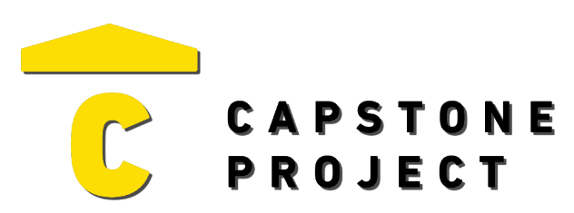
USER FEEDBACK
User Name: Dailyon Pontious
What are your thoughts on the project overall?
I believe that William has put in the work to accomplish his goals. He has done a good job.

Was the project enjoyable? What was your favorite part of the project?
The project was straight forward and intuitive.
What changes would improve the project?
Fix the database issue.

Capstone Project Ratings:
Project Technology Depth (shows good usage of technology) | High
Project Breadth (number of features and content) | Medium
Professional Presentation (analogous to a real-world product) | High
Implementation Quality (number of bugs and errors) | Medium
Project Completeness (project contains essential functionality) | Medium

Game / Application / Website Ratings:
Visuals (art style, environment, effects) | Positive
Audio (sound effects, music) | Very Negative
UI (title, menus, UI elements, text) | Positive
Controls (intuitive, ease of use, ease of navigation) | Positive
Interactivity (fun, engagement, flow) | Positive

